UXP-HTML5-L2-0001: User Registration Form

Level: L2

Technologies: HTML5, Css3, Bootstrap**.**

Case Study: To Create User Registration Form.

**Tips to start**

**Case Study – HTML User Registration Form**

Visual:

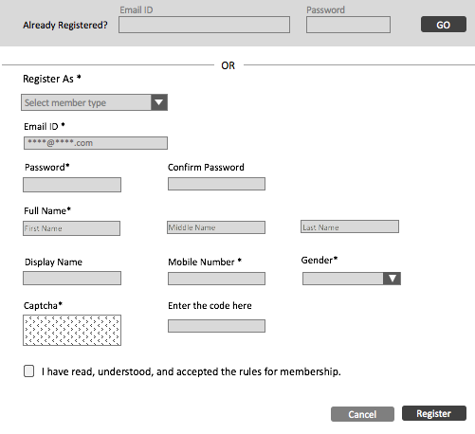

**Getting Started:**

Bootstrap your HTML page, create a HTML5 page with CSS3.

**Dependencies:**

Develop html page using bootstrap framework. Refer the links below.

Bootstrap: <http://getbootstrap.com/>

**Additional notes:**

* Create a table in HTML5.
* Create a Form with the fields as shown in the Picture above.
* Use placeholders for the input fields.
* <table><tr><td> (rigid table component) should not be used. Utilize fluid structure concepts.
* View should be responsive in all devices.